Lesson 04 Demo 01
Setting up a Grafana Instance

Objective
To install Grafana, start the Grafana server, and access the dashboard for monitoring and visualization.

Lesson 04 Demo 02
Building a Multi-Panel Dashboard in Grafana-
Objective
To connect Prometheus with Grafana and create a multi-panel monitoring dashboard using Node Exporter metrics.
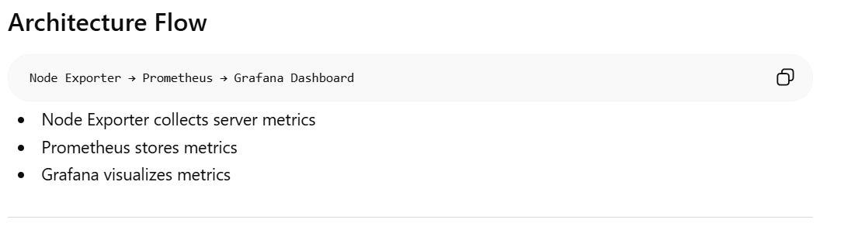

Lesson 04 Demo 03
Configuring Email Alerts for Critical System Thresholds
In this lesson, you are learning how to build a complete monitoring and alerting system using:
- Prometheus
- Grafana
- Node Exporter
--------------------------------------------------------------------------------------

Lesson 04 Demo 05
Setting up Docker Monitoring Using Prometheus and Grafana

You are building a Docker monitoring system using four main components:
- Docker → runs containers
- Prometheus → collects metrics
- Grafana → displays dashboards and graphs
- cAdvisor + Node Exporter → expose Docker and host machine metrics
The overall goal is:
Monitor your Linux machine and Docker containers in real time and visualize everything in Grafana dashboards.

Lesson 05 Demo 01
Setting up and Configuring Elasticsearch for Log Storage

In this demo, you are learning how to use Elasticsearch as a log storage and monitoring system.
Think of Elasticsearch like this:
Application Logs → Elasticsearch → Search / Analyze / Monitor
Instead of storing logs in text files, Elasticsearch stores them in indexed JSON documents, making logs searchable in real time
What You Are Doing in This Demo
You will:
- Verify Elasticsearch is running
- Create an index (like a database/table)
- Store log data
- Retrieve log data
- Delete the index

Why companies use Elasticsearch
Companies use it for:
- server monitoring
- Docker logs
- Kubernetes logs
- security monitoring
- application debugging
- observability
Popular stack:
- Elasticsearch → stores/searches logs
- Logstash/Filebeat → collects logs
- Kibana → visual dashboards
This is called the ELK Stack:
- E = Elasticsearch
- L = Logstash
- K = Kibana

- Lesson 05 Demo 02
- Building Logstash Pipelines for Centralized Log Collection

Why This Is Useful
Without centralized logging:
- logs are scattered
- debugging is difficult
- searching is slow
With Logstash + Elasticsearch:
- all logs in one place
- searchable instantly
- real-time monitoring
- alerts possible

Lesson 05 Demo 03 — Building Dashboards and Visualizations in Kibana
Objective
To build dashboards and visualizations in Kibana for monitoring application performance and system health, helping quickly identify issues.
Tools Required
- Kibana
- Elasticsearch
- Logstash
Prerequisites
- Elasticsearch installed and running
- Kibana installed and running
- Logstash configured with /etc/logstash/logstash.conf
- • Logstash → Ingest/process logs
- • Elasticsearch → Store/search data
- • Kibana → Dashboards/monitoring

- Lesson 05 Demo 04
- Configuring Filebeat to Collect Logs from Applications and Systems
- 